Batch: C3 Roll No.: 16010123217

Experiment No. ___9___

Grade: AA / AB / BB / BC / CC / CD /DD

Signature of the Staff In-charge with date

Title: Study, Implementation and Analysis of 8-Queens problem.

Objective: To learn the Backtracking strategy of problem solving for 8-Queens problem
CO to be achieved:

Sr. No | Objective
CO 1 | Compare and demonstrate the efficiency of algorithms using asymptotic complexity notations.
CO 2 | Analyze and solve problems for divide and conquer strategy, greedy method, dynamic programming approach and backtracking and branch & bound policies.

Books/ Journals/ Websites referred:
- Ellis horowitz, Sarataj Sahni, S.Rajsekaran,” Fundamentals of computer algorithm”, University Press
- T.H.Cormen ,C.E.Leiserson,R.L.Rivest and C.Stein,” Introduction to algortihtms”,2nd Edition ,MIT press/McGraw Hill,2001
- http://www.math.utah.edu/~alfeld/queens/queens.html
- http://www-isl.ece.arizona.edu/ece175/assignments275/assignment4a/Solving%208%20queen%20problem.pdf
- http://www.slideshare.net/Tech_MX/8-queens-problem-using-back-tracking
- http://www.mathcs.emory.edu/~cheung/Courses/170.2010/Syllabus/Backtracking/8queens.html
- http://www.geeksforgeeks.org/backtracking-set-3-n-queen-problem/
- http://www.hbmeyer.de/backtrack/achtdamen/eight.htm

Pre Lab/ Prior Concepts:
Data structures, Concepts of algorithm analysis

Historical Profile:
The N-Queens puzzle is the problem of placing N queens on an N×N chessboard so that no two queens attack each other. Thus, a solution requires that no two queens share the same row, column, or diagonal.

New Concepts to be learned:
Application of algorithmic design strategy to any problem, Backtracking method of problem-solving Vs other methods of problem solving, 8- Queens problem and its applications.

Algorithm N Queens Problem: -

void NQueens(int k, int n)
// Using backtracking, this procedure prints all possible placements of n queens on an n X n chessboard so that they are nonattacking.
{ for (int i=1; i<=n; i++)
{
if (Place(k, i))
{
x[k] = i;
if (k==n)
for (int j=1;j<=n;j++) Print x[j] ;
else NQueens(k+1, n);
}
}
}

Boolean Place(int k, int i)
// Returns true if a queen can be placed in k^{th} row and i^{th} column. Otherwise it returns false.
// x[] is a global array whose first (k-1) values have been set. abs(r) returns absolute value of r.
{
for (int j=1; j < k; j++)

if ((x[j] == i) // Two in the same column

|| (abs(x[j]-i) == abs(j-k))) // or in the same diagonal
return(false);
return(true);

}

Example 8-Queens Problem:

The eight queens puzzle is the problem of placing eight chess queens on an 8×8 chessboard so that no two queens threaten each other i.e. no two queens share the same row, column, or diagonal.

Solution Using Backtracking Approach:

The idea is to place queens one by one in different columns, starting from the leftmost column. When we place a queen in a column, we check for clashes with already placed queens. In the current column, if we find a row for which there is no clash, we mark this row and column as part of the solution. If we do not find such a row due to clashes then we backtrack and return false.

State Space tree for N-Queens (Solution):

For N = 4:

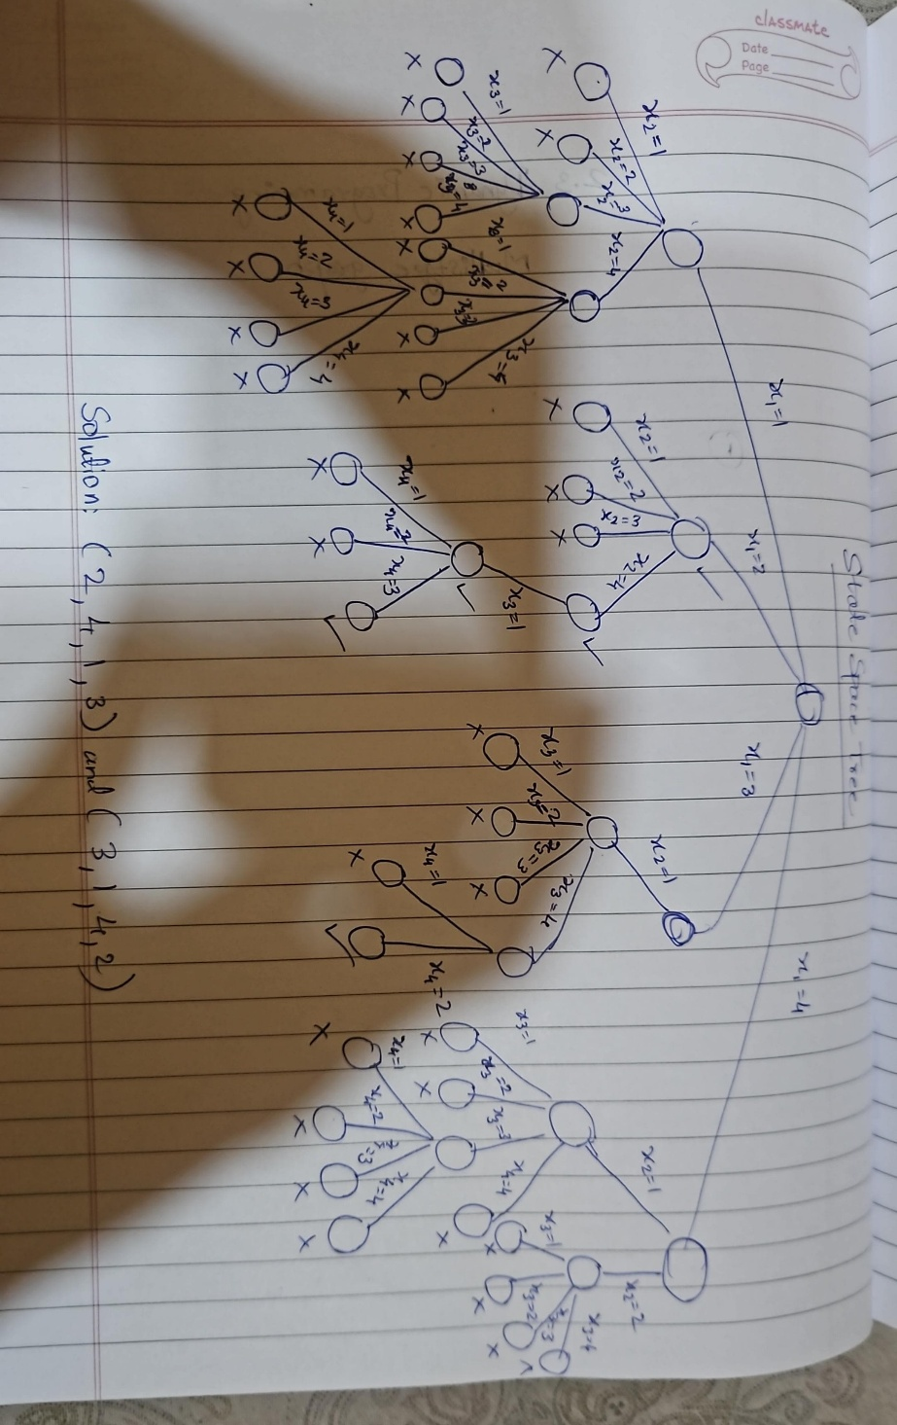

Implementation (Code):

#include <bits/stdc++.h>
using namespace std;
#define int long long
#define endl "\n"

const int MOD = 1e9 + 7;
const int INF = LLONG_MAX >> 1;

bool isSafe(vector<string>& board, int row, int col, int n){
for(int i = 0; i < row; i++){
if (board[i][col] == 'Q') return false;
}

for(int i = row, j = col; i >= 0 && j >= 0; i--, j--){
if (board[i][j] == 'Q') return false;
}

for(int i = row, j = col; i >= 0 && j < n; i--, j++){
if (board[i][j] == 'Q') return false;
}

return true;
}

void solNQ(int row, vector<string>& board, vector<vector<string>>& ans, int n){
if(row == n){
ans.push_back(board);
return;
}

for(int col = 0; col < n; col++){
if (isSafe(board, row, col, n)) {
board[row][col] = 'Q';
solNQ(row + 1, board, ans, n);
board[row][col] = '_';
}
}
}

signed main(){
cout<<"Enter the size of chess board:\t";
int n; cin>>n;

vector<string> board(n, string(n, '_'));
vector<vector<string>> ans;

solNQ(0, board, ans, n);

cout<<"Number of solutions: "<<ans.size()<<endl;

for (int i = 0; i < ans.size(); i++){
cout << "Solution "<<i+1<<":"<<endl;
for (const string& row : ans[i]){
cout<<row<<endl;
}
cout<<endl;
}

return 0;
}

OUTPUT:

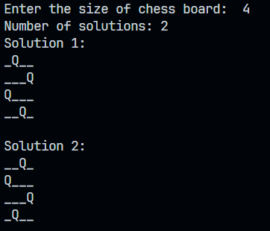

Algorithm:
solve(row):
- If row equals N (all queens placed), add the current board configuration to solutions and return.
- For each column from 0 to N-1:
  - If placing a queen at (row, column) is isSafe():
    - Place a queen at (row, column).
    - Recursively call solve(row + 1).
    - Remove the queen from (row, column) (backtrack).
isSafe(row, column):
- Check if there is a queen in the same column above the current row.
- Check if there is a queen in the upper-left diagonal.
- Check if there is a queen in the upper-right diagonal.
- Return true if safe, false otherwise.

Analysis of Backtracking solution:

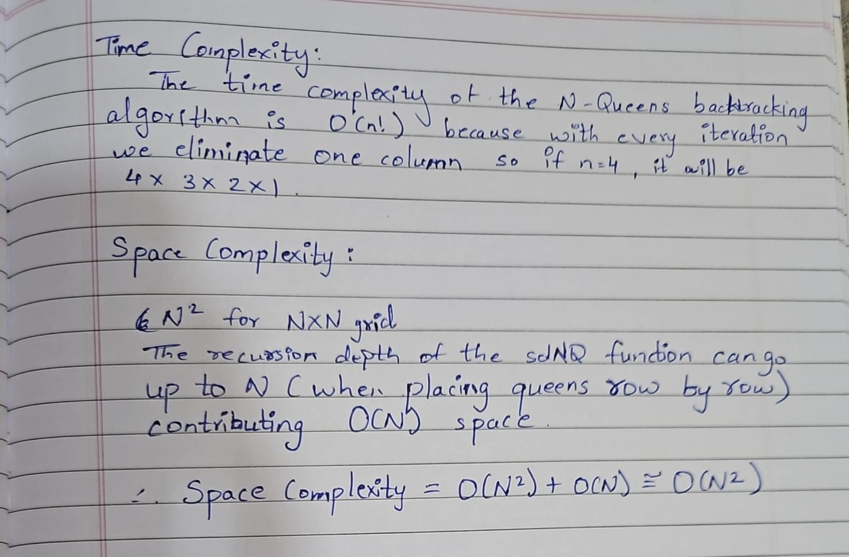

CONCLUSION:

From this experiment, we learnt about n-queen problem using backtracking solution

